Development of a EEG Biopotential Amplifier

A Project Submitted

By

S.S.Mukesh(CB.EN.U4ELC19030)

Hemprasanna A.(CB.EN.U4ELC19017)

* 1. Block Diagram of the Project

This block diagram describes the overview of our project. Firstly we will put the bio-signal from the AC voltage source then through the bio-amplifier to the oscilloscope.

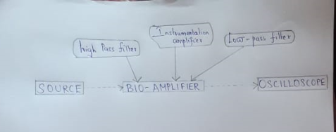

Figure 1.4 Block diagram of this project.

* 1. Future Scope of this Project

The work presented in this project can be extended in several directions. The project can be extended to:

* To design better EEG signal circuit.
* To design more accuracy in EEG signal receiving.
* To design the modular for commercial purpose.

**Bio-amplifier for EEG**

High performance differential amplifiers are used for amplification. Signals of interest are in the range of 0.5-100v, over the frequency range of 1-50Hz.similar . EED benefits from the usage of Integrated circuit. Some minimal specifications for a modern EEG amplifier includes:

* Low interval voltage and current noise
* High input impedance
* Bandwidth
* Frequency cutoffs
* High common mode rejection ratio
* Common mode input range
* Static electricity shock protection
* Gain stability > ±1%

Equipment

* AD623 instrumentation amplifier.
* TL071 Op-amp.
* Resistors: 10Ω, 10kΩ, 47kΩ, 100kΩ, 180kΩ, 200kΩ, 220kΩ.
* Capacitors: 1nF, 33nF, 100nF, 220nF.
* Diode
  + 1. Design the Circuit

To make the design process easier the filter circuit was divided into 4 different steps.

These steps are:

* A Right-leg driven circuit.
* An Instrumentation amplifier.(AD623)
* Two 50Hz notch filter.
* A 7Hz High pass filter.
* A 13Hz Low pass filter (2nd order).
* A 13Hz Low pass filter (4th order).

**CIRCUIT IMPLEMENTATION**

In circuit construction components like resistors have to be exactly same as equations. If exact valued components were not used the desired values, frequency range, cut-off frequency and gain will be changed. Hence the output will be changed. The op-amps with the same model number but manufactured in different facilities usually have different pin numbers. This should be checked before implementing the circuit. Noise free cables must be used to document input and output curves

Electroencephalogram (EEG)

Electroencephalogram (EEG) is a test used to evaluate the electrical activities in the brain. Brain cells communicate with each other through impulses .

**Biopotential Interfacing circuit for EEG**

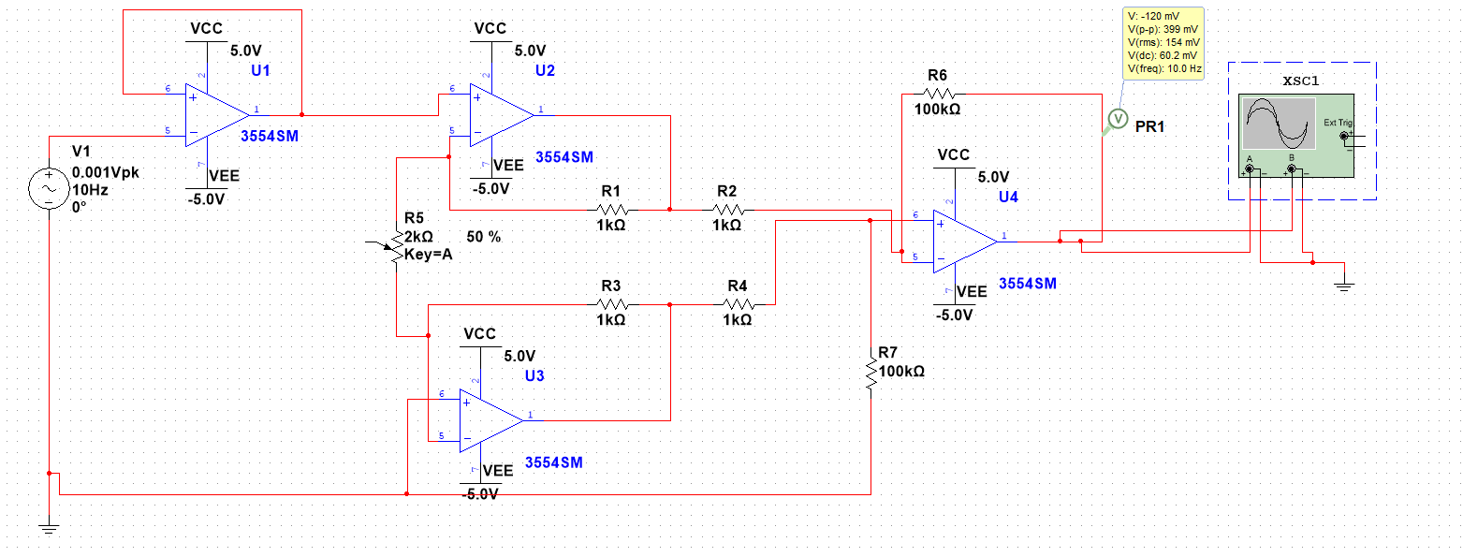

**OUTPUT:**

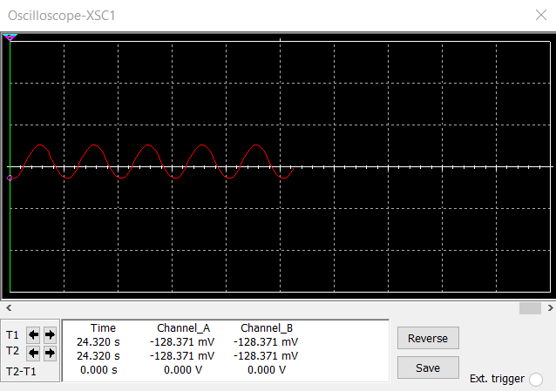

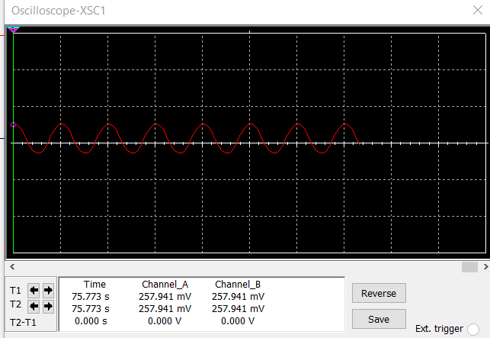

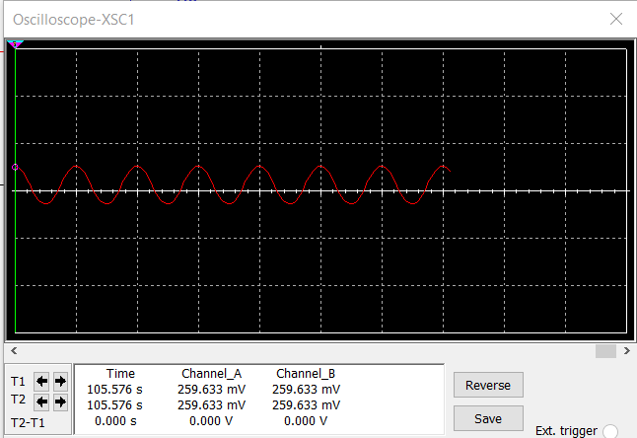

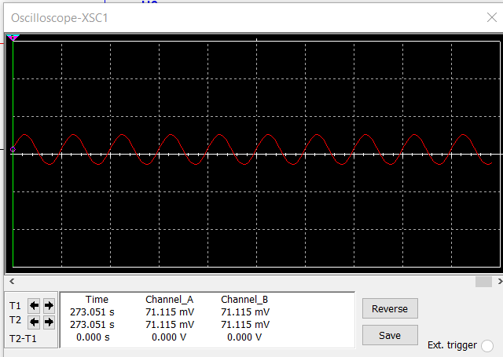

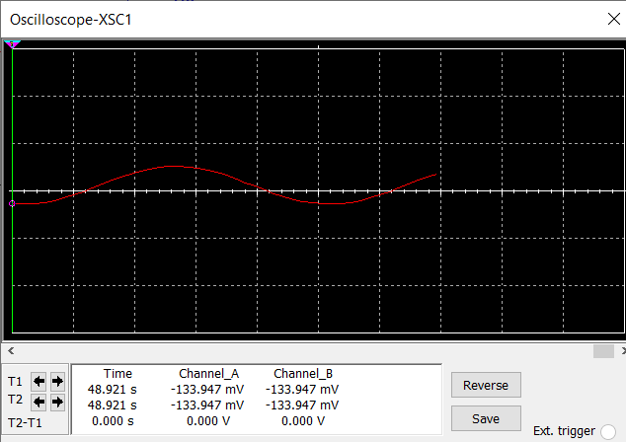

Right-Leg Driven Circuit

Right-Leg Driven Circuits are used with biopotential differential amplifiers to reduce common mode voltage.

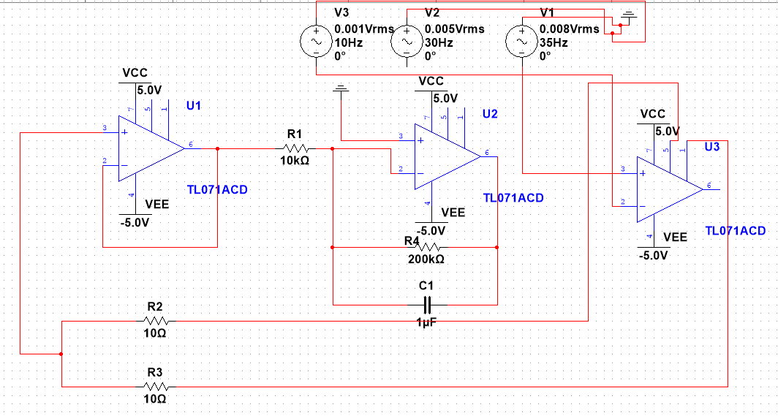

Instrumentation Amplifier

The voltage level of ECG signal is 100 µV to 2mV. To make this signal usable for other filter circuits a great deal of amplification is required. That is the reason behind the application of the circuit. The AD620 operational amplifier was used to this specific range of the signal. Instrumentation amplifier has a high gain. The amount of this operational amplifier is determined by a gain resistor. From the gain formula,

$G=(1+\frac{49400}{50})$ $$=989$$

Where, R is 50Ω.

50 Hz Notch-Filter

The filter is actually known as twin T notch filter. The center rejection frequency of this circuit is determined by,

$f=\frac{1}{2π}\sqrt{\frac{1}{C2*C3*R3*(R1+R2)}}$……………………………...………3.2

Using the equation 3.2,

$$f=\frac{1}{2π}\sqrt{\frac{1}{\left(100*{10}^{-9}\right)*\left(100*{10}^{-9}\right)*\left(10*{10}^{3}\right)*\{\left(47*{10}^{3}\right)+\left(47*{10}^{3}\right)\}}}$$

$$=51.93 Hz$$

7 Hz High Pass Filter

To cut off Delta and Theta waves, which have frequencies below 7Hz, a 7Hz high pass filter was needed. A 2nd order multiple-feedback high-pass filter was used to cut off those unwanted signals.

The equation of cut-off frequency is,

$f=\frac{1}{2π\sqrt{R1*R2*C2*C3}}$………………………………3.3

For finding cut-off frequency equation 3.3 is used,

$$f=\frac{1}{2*3.1416\sqrt{\left(220*{10}^{3}\right)*\left(220*{10}^{-9}\right)*\left(220*{10}^{-9}\right)*\left(47*{10}^{3}\right)}}$$

$$=7.11 Hz$$

The equation of the gain is,

$G=\frac{c_{1}}{c_{2}}$………………………………………………………3.4

Using equation 3.4,

G=((220 * 10(^-9))/ (220 * 10(^-9)))

G=1

**13 Hz Low Pass Filter**

Since the frequency of the alpha wave is 8-12 Hz. A low pass filter circuit is needed that will cut off any frequency above 12 Hz. In the ideal case, the cut-off frequency of the low-pass filter would be 12 Hz. But in the practical scenario, the gain starts to drop quite before the cut-off frequency. In that case using a 12 Hz low pass filter would cause a data loss. That is why a 13 Hz low pass filter was chosen so that there is less attenuation in an alpha wave.

For finding cut-off frequency equation 3.3 is used,

$$f=\frac{1}{2*3.1416\sqrt{\left(220*{10}^{3}\right)*\left(100*{10}^{-9}\right)*\left(33*{10}^{-9}\right)*\left(180*{10}^{3}\right)}}$$

$=13.8 Hz$

**Error Budgetting**

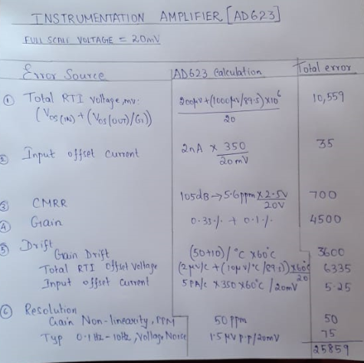

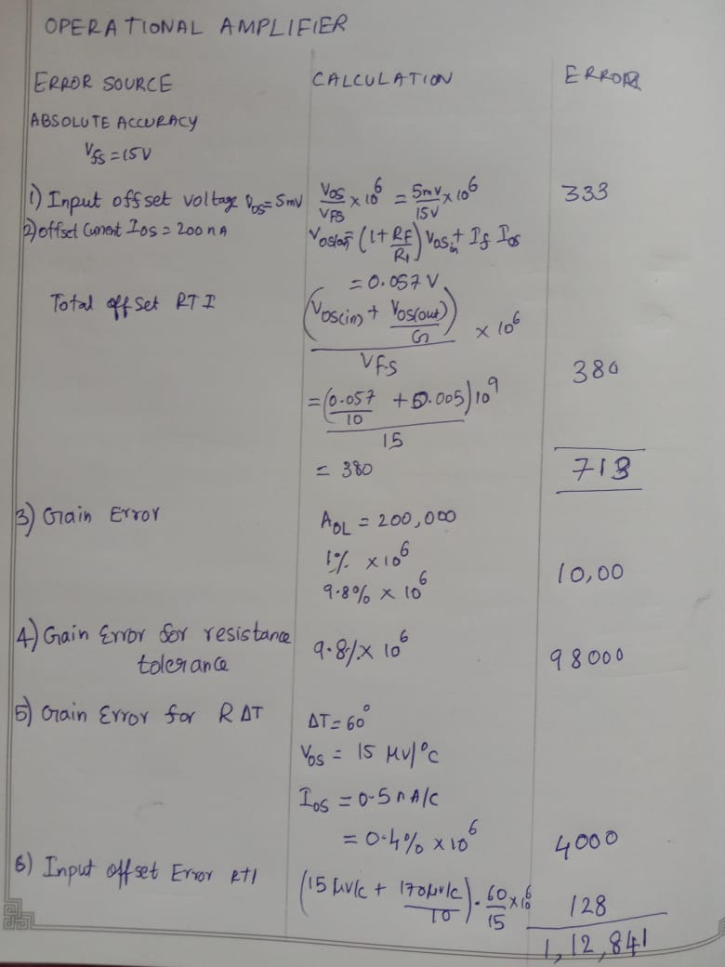

**Limitation Of the circuit**

Many abnormal patterns on an EEG may be non-specific, meaning that they may be observed with a verity of different conditions. They may be a normal variant and not reflect any abnormality at all.Environmental signal, meaning that signal from other electrical parts can be a cause of getting imperfect waveform from the modular device.